**Technical design document**

***Kwetter***

|  |
| --- |
| **Date : 20/03/2024** |
| **Version : 1.0** |
| **State : Developing** |
| **Author : Saeed Ba Wazir** |

Version history

|  |  |  |  |  |
| --- | --- | --- | --- | --- |
| **Version** | **Date** | **Author(s)** | **Changes** | **State** |
| 1.0 | 20/03/2024 | Saeed Ba Wazir | Adding Introduction, Architecture overview, security design and deployment plan sections. | developing |
|  |  |  |  |  |
|  |  |  |  |  |

**Distribution**

|  |  |  |
| --- | --- | --- |
| **Version** | **Date** | **Receivers** |
|  |  |  |
|  |  |  |

Contents

**1.** **Introduction** 4

**2.** **Architecture overview** 4

**3.** **Security Design** 7

**4.** **Deployment Plan** 7

# **Introduction**

Our project aims to develop a user-friendly social media application, a popular microblogging platform. Designed to facilitate real-time communication through concise messaging, our platform seeks to foster meaningful connections among users. By prioritizing user experience and leveraging ICT capabilities, we aim to deliver a competitive edge in the digital landscape while contributing to our company's growth and market positioning.

# **Architecture overview**

For the architecture overview we created C1 and C2 levels of the [C4 model](https://c4model.com/). C4 diagrams are utilized for architecture overview because they provide scalability, accommodating systems of various sizes, and abstraction levels, enabling representation from high-level contexts to detailed components.

The C1 diagram below displays how the users are going to interact with the system.

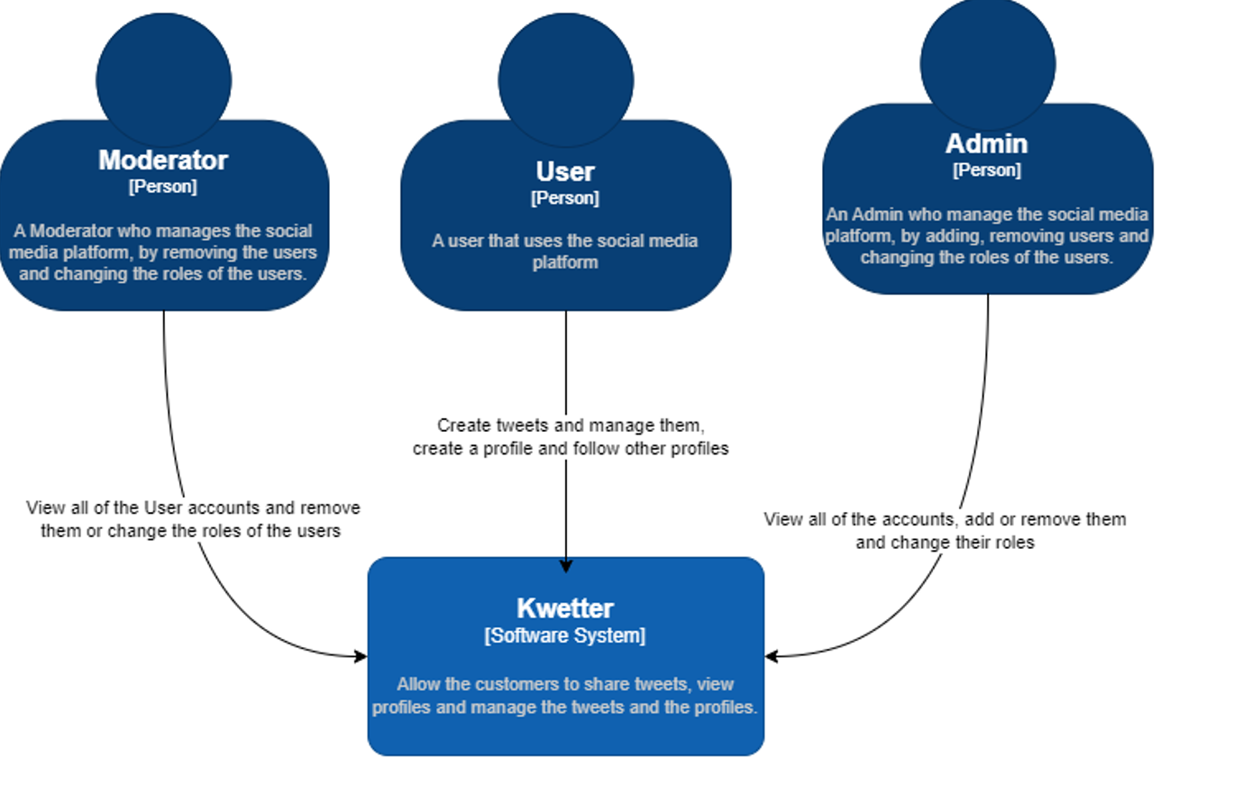

Figure 1. C1 level of C4 diagram.

The C2 diagram foucses more into what are the containers of the system and how the high level components works together. As the diagram below shows we will have a web application, connected to ApI-gateway and the API-gateway connects to services.

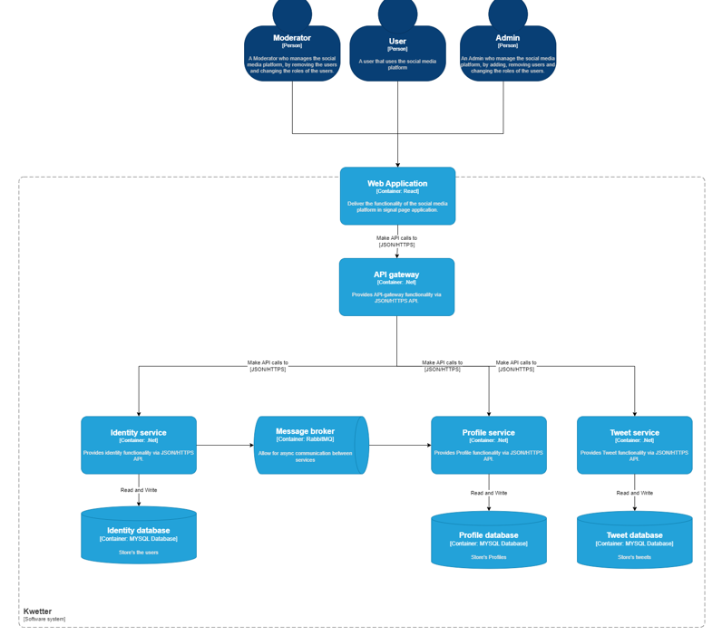 Figure 2. C2 level of C4 diagram.

**Sequence diagram**

The diagram illustrates the process of creating a user profile and demonstrates how the various services collaborate to achieve this goal. Figure 3. Create a profile sequence diagram.

# **Security Design**

In this project, we will implement a base role for Authentication and Authorization, ensuring that users are authenticated and authorized based on their roles and permissions.

Additionally, we will prioritize security measures such as Data Encryption to safeguard sensitive data both in transit and at rest. This involves encrypting communication channels using protocols like SSL/TLS and encrypting data stored in databases or files using encryption algorithms.

Moreover, Secure Communication will be enforced to ensure that communication between system components and external systems is secure and tamper-proof. This will include using secure communication protocols like HTTPS, enforcing encryption and authentication for API calls, and implementing secure communication channels such as VPNs or secure tunnels.

Furthermore, Security Auditing and Logging will be integral to the system's design, enabling the logging of security-related events and activities for monitoring and auditing purposes. This includes implementing logging mechanisms to record access attempts, security breaches, and suspicious activities, and utilizing auditing tools to analyze logs for security incidents.

Lastly, Secure Configuration and Deployment practices will be followed, ensuring that systems are configured with secure settings and deployed using secure practices. This involves hardening system configurations, patching vulnerabilities regularly, and adhering to secure deployment practices such as least privilege and separation of duties.

# **Deployment Plan**

This section details the procedures and strategies for deploying the software to production environments, ensuring a smooth transition from development to live operation.

Rollout Strategy:

In this project, we will implement a gradual rollout strategy. Initially, the software will be released to a subset of users for controlled testing and verification before full-scale deployment.

Testing and Verification:

Procedures are specified for testing and verifying the deployment to ensure proper functioning in the production environment. This includes conducting functional testing to validate feature functionality and security testing to identify and address vulnerabilities.

Monitoring and Maintenance:

Procedures are outlined for monitoring and maintaining the deployed software. Tasks include monitoring system performance, logging and analyzing errors, applying patches and updates, and addressing any post-deployment issues.

Rollback Strategy:

Procedures are specified for rolling back the deployment in case of unforeseen issues or failures. This involves identifying rollback points, backing up data and configurations before deployment, and implementing procedures for reverting to a previous version if necessary.

This section ensures that the deployment process is well-documented and executed, minimizing risks and ensuring the successful operation of the software in the production environment.